For every instrument there are pieces of literature that are a staple, a standard. For saxophone, one such piece is Bernhard Heiden’s Sonata in Eb for Alto Saxophone and Piano. The piece has become a staple of saxophone literature because of the technique required to play the piece, the different creative elements used by the composer and the historical importance of it to saxophone literature. To understand how these elements have come to make Heiden’s Sonata such an influential piece in saxophone literature we will look at in-depth analysis of the Sonata’s historical importance and the different creative techniques used within the Sonata.
To understand the importance of the Heiden sonata we must start from the beginning of classical saxophone literature. In 1838, the saxophone was invented by Antoine Joseph “Adolph” Sax, a Belgium inventor (Beeson). Sax became the first performer and teacher of the saxophone to help his new instrument grow in popularity (Beeson). Many soloists began to spread the instrument through out Europe and the first performance that documents the use of a saxophone in America occurred December 19th 1853 (Angeli). The saxophone slowly began to grow more in more popular in band literature and it’s use in works by composers like John Phillip Sousa helped to increase this popularity even more (Beeson). It wasn’t until the 1920’s that many American composers began to compose classical solo literature for the saxophone with the first Sonata being in 1928 (Beeson). For a while it was believed that Heiden’s Saxophone was the first Sonata written for saxophone.
“Londeix was compiling information for his book 225 Years of Music for Saxophone which was published by Leduc in 1971. Heiden recounts, ‘I met him and he said he had written a book on saxophone. He said that it (Sonata) was the first; that was the source.’ However, Londeix's recent update of his book, 150 Years of Music for Saxophone, lists at least eight sonatas for alto saxophone and piano composed before 1937” (Walsh).

Regardless of which saxophone Sonata came first, the one written by Bernhard Heiden has stood the test of time as one of the most influential. The fact that many thought this piece was the first Sonata written helps to prove its importance to Saxophone literature.
Now that we’ve briefly covered the history of the saxophone up until the point of Heiden’s Sonata we need to also understand the history of the composer. Heiden was born on August 24th 1910 in Frankfurt Germany (Kozin). He began music training at the age of five with ear training, rhythm and dictation exercises and shortly afterwards began piano lessons (Walsh). When he turned fifteen Heiden studied with Bernhard Sekles (Walsh). At this time Heiden continued to study piano, studied Violin for 4-5 years, and began Clarinet lessons (Walsh). Heiden studied at the Hochschule fur Musik from 1929-1933 and received a degree in conducting (Walsh). While at the Hochschule fur Musik Heiden studied composition with Paul Hindemith, who was always very critical of Heiden’s compositions (Beeson). After leaving the Hochchule, Heiden took a position playing clarinet for the Jewish-Kulturbund Orchestra who even premiered one of his pieces. He also married Cola de Joncheere, a pianist (Walsh). In 1935 the Heidens moved to Detroit, Michigan to avoid the difficulties of being a Jew in Germany during that time period (Kozin). It was here in Detroit where he wrote his Saxophone Sonata and it wouldn’t have happened had it not been for Larry Teal, a prominent saxophone educator and performer who also lived in Detroit at the time.
While Teal was not the first time that Heiden had heard the saxophone, he was the first saxophonist that Heiden became close to (Walsh). Teal allowed many musicians to have studios within his home – one of whom was Heiden’s wife (Walsh). It was through this the Heidens and the Teals became good friends with Mr. and Mrs. Heiden accompanying Teal during performances. Teal had heard at least one of Heiden’s compositions and he asked Heiden to write something for him (Walsh). “I didn’t write the Sonata because I knew the saxophone. I wrote the Sonata because I knew Teal, who happened to play the saxophone,” says Heiden (Liley). While the Sonata was written in 1937 it wasn’t published until 1944 by Schott Music (Mauk). Even though this piece has been one of the most performed of Heiden’s pieces for saxophone it’s interesting to note he hasn’t made money off of the individual sales. Heiden sold all the rights to Schott music for 75 dollars, which was the most money he’d seen at the time, and as a new composer he didn’t have the reputation to renegotiate with Schott’s proposed contract (Walsh).
While a Sonata is broken down into three movements. The first movement is marked Allegro and follows the basic Sonata-Allegro form. However he does make some small changes to the form. The principal melody has a march-like quality to it, and is composed of four smaller motives (Walsh). The Figure from Thomas Walsh’s analysis of the sonata shows how the piece fits basic Sonata Allegro Form but also shows the twists it adds – like the development theme (D) (Walsh).
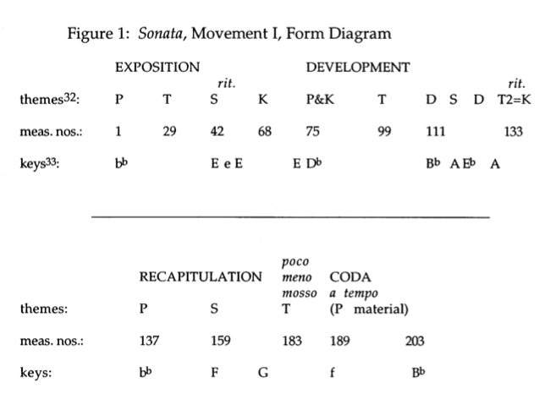
You can also see the key areas form a variation from traditional Sonata-Allegro form. The second theme of the exposition is usually presented in the dominant but Heiden has decided to present in a tri-tone from the tonic key and a half step below the dominant – which he uses at the beginning of the recapitulation (Walsh). This adds some variance to the piece that makes it a creative and interesting piece.
The second movement of the piece follows a Rondo form (Walsh). One thing that Walsh points out is his analysis is the combination of the themes in the C section (Walsh). It’s interesting how the piano and saxophone parts switch the theme that they have at measure 166 and 178. This movement is marked scherzo and features a driving tempo that pushes through the entire piece (Schott). Walsh also points out that the phrases throughout the piece are all elided and run into each other (Walsh). This continues until the end where you have the first real cadence of the piece (Walsh).

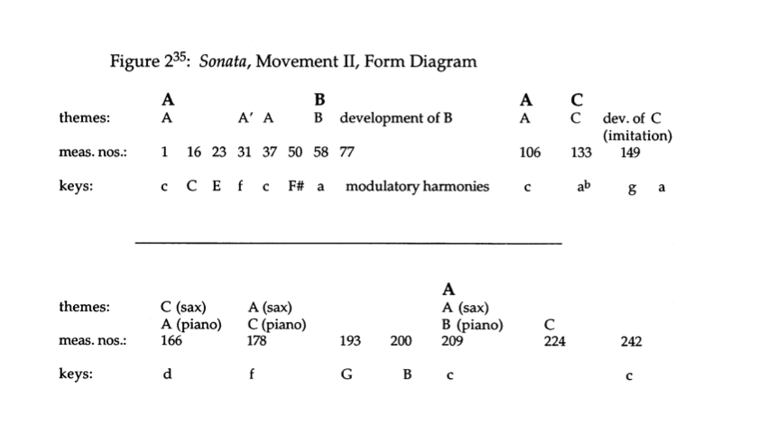
The third movement has the most interesting form of all the movements. This movement is broken up into two different forms (Walsh). The beginning adagio section follows an A-B-A form. The second form is a Rondo beginning at the presto and going through the end of the piece and includes the themes from the adagio section. The tempo in this movement varies throughout going from adagio to presto then briefly to adagio for a short recap of the beginning theme and ends with a presto molto vivace (Schott). The adagio theme features a dance-like siciliano rhythm and the presto contains a theme based on major and minor seconds (Walsh).
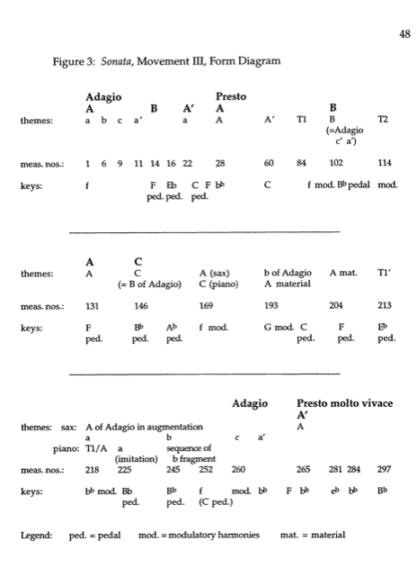
I think it’s also important to note the overall form of the Sonata reflects the common structure for most multi-movement works. This is significant as Heiden, like his teacher Hindemith, use a lot of classical forms and ideas in their writing. The first movement is in Sonata-allegro form, which is typical of almost all Sonatas. The second movement is a Scherzo in Rondo form. The final movement combines what could almost have been two separate movements. The adagio in the third movement uses Siciliano rhythms, which is a type of slow dance, and the presto/presto molto vivace bring the piece to a climactic ending.
One technique that Heiden uses throughout his saxophone Sonata is thematic unity. Thematic Unity is when themes share a lot of traits in common within a single movement or different movements of a multi-movement work. One example of this is the first two measures as well as measures nine through ten of the first movement and the A themes of both the adagio and presto sections of the third movement.
Thematic Unity
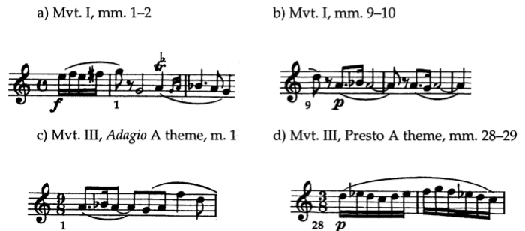
When you put these different pieces together you can see the intervallic and melodic similarities shared between the four different lines.
Another example of thematic unity connects the second and third movements. A hemiola pattern in measures 96-99 of movement III mimic the intervals and rhythm present in one of the themes in the second movement with one example being measures 229-230.
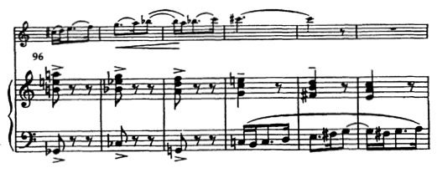
Mvmt 3 measure 96-101
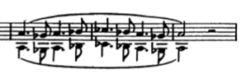
Movement 2 measure 229-230
While the intervallic content is not exactly the same. The two are strikingly similar and you can tell the line in movement three references the line presented earlier in movement two.
Another creative technique that Heiden used frequently in his saxophone Sonata is the use of hemiola – a two pattern over a three pattern or vice versa. This happens many times throughout the different movements of the Sonata the most occur during the third movement.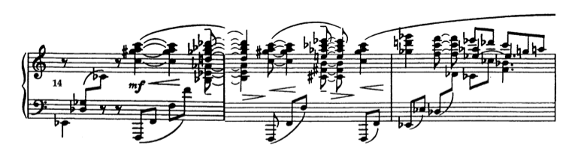
movement 3 measure 14-16
The hemiola in the example above begins with the quarter note pick up from measure 15 into through measure 16. Even though the piece is in 9/8 the piano part has a duple pattern that creates a hemiola effect.
Another example of a hemiola occurs later in the piece from measure 37-42
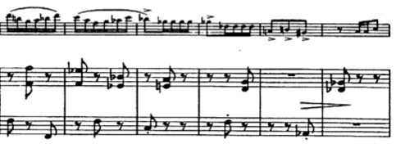
mvmt 3 measure 37-42
While the saxophone part is playing eighth and sixteenth note patterns the piano has the two eighth note patterns again creating another hemiola. This is a common technique Heiden used throughout his Sonata.

One last technique used by Heiden is metric displacement. Metric displacement is accenting a beat other than one to create an off meter feel. Heiden does this in a couple spots throughout his Sonata. One example is the end of the first movement.
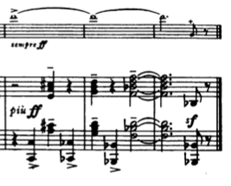
While the saxophone part sustains a pitch the piano part has a rhythm with off beats accented. This creates a feeling of the measure being unbalanced, which he resolves, with the last note of the piece.
Anther example of metric displacement occurs during the final movement. Rather than use a different accent pattern, Heiden achieves this metric displacement using the articulation pattern of the saxophone.
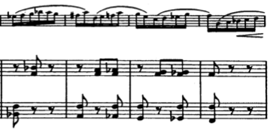
Mvmt 3 measure 145-148
Rather than have the saxophone articulate the first notes of each measure, Heiden has the saxophone articulate the third note of measures 146 and 147 and the second note of 148. This creates a form a metric displacement because the articulations naturally accent those notes.
There is a lot more to Heiden’s Saxophone Sonata that make it an interesting piece. It has a rich history as one of the most important early saxophone sonatas, as the first piece written for saxophone by Bernhard Heiden, it’s relationship to Larry Teal – an important saxophone educator, and it’s impact on classical saxophone. It also has a rich form and unique form that makes it interesting from a musical theory stand point as well. The different compositional techniques used by Heiden connect the different movements of the Sonata and bring it all together. These reasons all connect and make it obvious why this is a staple piece of saxophone literature.

Works Cited
Angeli, Giacomo. Classical and Jazz Saxophone: Two faces to the same Instrument. Helsinky Metropolia University of Applied Sciences. 2013. Web. <http://theseus.fi/bitstream/handle/10024/60063/Angeli_Thesis_15_05_13.pdf?sequence=1>.
Beeson, Robert E. THE SAXOPHONE SONATA IN TWENTIETH CENTURY AMERICA: CHRONOLOGY AND DEVELOPMENT OF SELECT REPERTOIRE. Diss. University of Maryland, 2011. College Park. Web. <http://drum.lib.umd.edu/bitstream/1903/12882/1/Beeson Diss. Final.pdf>.
Heiden, Bernhard. “Sonata for Saxophone in Eb and Piano”. New York. Schott. 1943.
Kozinn, Allan. "Bernhard Heiden, 89, Composer and Indiana University Professor." New York Times 14 05 2000, Late Edition 42. Web. 8 Apr. 2014. <http://0-www.lexisnexis.com.rosi.unk.edu/hottopics/lnacademic/?verb=sr&csi=6742&sr=HLEAD(Bernhard Heiden, 89, composer and Indiana University professor) and date is 2000>.
Liley, Thomas. Larry Teal: There will never be another you. North American Saxophone Alliance, 2008. Print.
Mauk, Steve. "Bernhard Heiden's Sonata for Saxophone." Saxophone Journal. (1995): 56-61. Web. 4 Apr. 2014. <http://faculty.ithaca.edu/mauk/docs/heidensonata.pdf>.
Rousseau, Eugene. “Heiden: Sonata”. Saxophone Masterpieces. RIAX. 2000. CD.
Walsh, Thomas. A Performer's Guide to the Saxophone music of Bernard Heiden. Diss. Indiana University School, 1999. Indiana University, Web. <https://scholarworks.iu.edu/dspace/handle/2022/328>.
WSCXVI Eugenne Rousseau Master Class Essential Historic Repertoir II:Creston, Ibert and Heiden. YouTube, Film. 8 Apr 2014. <http://www.youtube.com/watch?v=g1nk0R0Ty_k>.
Wytko, Anna M. “Heiden: Sonata”. “When Night Came. TimeGrabber Digital. 2011. CD.

